Tic tac toe python code

Tictactoe.py :

import math

import copy

X = "X"

O = "O"

EMPTY = None

def initial_state():

    #Returns starting state of the board.

    return [[EMPTY, EMPTY, EMPTY],

            [EMPTY, EMPTY, EMPTY],

            [EMPTY, EMPTY, EMPTY]]

def player(board):

    #Returns player who has the next turn on a board.

    xCounter = 0

    oCounter = 0

    for i in range(0, len(board)):

        for j in range(0, len(board[0])):

            if board[i][j] == X:

                xCounter += 1

            elif board[i][j] == O:

                oCounter += 1

    if xCounter > oCounter:

        return O

    else:

        return X

def actions(board):

    #Returns set of all possible actions (i, j) available on the board.

    possibleActions = set()

    for i in range(0, len(board)):

        for j in range(0, len(board[0])):

            if board[i][j] == EMPTY:

                possibleActions.add((i, j))

    return possibleActions

def result(board, action):

    #Returns the board that results from making move (i, j) on the board.

    # Create new board, without modifying the original board received as input

    result = copy.deepcopy(board)

    result[action[0]][action[1]] = player(board)

    return result

def winner(board):

    #Returns the winner of the game, if there is one.

    # Check rows

    if all(i == board[0][0] for i in board[0]):

        return board[0][0]

    elif all(i == board[1][0] for i in board[1]):

        return board[1][0]

    elif all(i == board[2][0] for i in board[2]):

        return board[2][0]

    # Check columns

    elif board[0][0] == board[1][0] and board[1][0] == board[2][0]:

        return board[0][0]

    elif board[0][1] == board[1][1] and board[1][1] == board[2][1]:

        return board[0][1]

    elif board[0][2] == board[1][2] and board[1][2] == board[2][2]:

        return board[0][2]

    # Check diagonals

    elif board[0][0] == board[1][1] and board[1][1] == board[2][2]:

        return board[0][0]

    elif board[0][2] == board[1][1] and board[1][1] == board[2][0]:

        return board[0][2]

    else:

        return None

def terminal(board):

    #Returns True if game is over, False otherwise.

    if winner(board) is not None or (not any(EMPTY in sublist for sublist in board) and winner(board) is None):

        return True

    else:

        return False

    #return True if winner(board) is not None or (not any(EMPTY in sublist for sublist in board) and winner(board) is None) else False # noqa E501

def utility(board):

    #Returns 1 if X has won the game, -1 if O has won, 0 otherwise.

    if terminal(board):

        if winner(board) == X:

            return 1

        elif winner(board) == O:

            return -1

        else:

            return 0

    # Check how to handle exception when a non terminal board is received.

def minimax(board):

    #Returns the optimal action for the current player on the board.

    if terminal(board):

        return None

    else:

        if player(board) == X:

            value, move = max_value(board)

            return move

        else:

            value, move = min_value(board)

            return move

def max_value(board):

    if terminal(board):

        return utility(board), None

    v = float('-inf')

    move = None

    for action in actions(board):

        # v = max(v, min_value(result(board, action)))

        aux, act = min_value(result(board, action))

        if aux > v:

            v = aux

            move = action

            if v == 1:

                return v, move

    return v, move

def min_value(board):

    if terminal(board):

        return utility(board), None

    v = float('inf')

    move = None

    for action in actions(board):

        # v = max(v, min_value(result(board, action)))

        aux, act = max_value(result(board, action))

        if aux < v:

            v = aux

            move = action

            if v == -1:

                return v, move

    return v, move

main.py:

import pygame

import sys

import time

import tictactoe as ttt

pygame.init()

size = width, height = 600, 400

# Colors

black = (0, 0, 0)

white = (255, 255, 255)

screen = pygame.display.set_mode(size)

mediumFont = pygame.font.Font("OpenSans-Regular.ttf", 28)

largeFont = pygame.font.Font("OpenSans-Regular.ttf", 40)

moveFont = pygame.font.Font("OpenSans-Regular.ttf", 60)

user = None

board = ttt.initial_state()

ai_turn = False

while True:

    for event in pygame.event.get():

        if event.type == pygame.QUIT:

            sys.exit()

    screen.fill(black)

    # Let user choose a player.

    if user is None:

        # Draw title

        title = largeFont.render("Play Tic-Tac-Toe", True, white)

        titleRect = title.get_rect()

        titleRect.center = ((width / 2), 50)

        screen.blit(title, titleRect)

        # Draw buttons

        playXButton = pygame.Rect((width / 8), (height / 2), width / 4, 50)

        playX = mediumFont.render("Play as X", True, black)

        playXRect = playX.get_rect()

        playXRect.center = playXButton.center

        pygame.draw.rect(screen, white, playXButton)

        screen.blit(playX, playXRect)

        playOButton = pygame.Rect(5 * (width / 8), (height / 2), width / 4, 50)

        playO = mediumFont.render("Play as O", True, black)

        playORect = playO.get_rect()

        playORect.center = playOButton.center

        pygame.draw.rect(screen, white, playOButton)

        screen.blit(playO, playORect)

        # Check if button is clicked

        click, _, _ = pygame.mouse.get_pressed()

        if click == 1:

            mouse = pygame.mouse.get_pos()

            if playXButton.collidepoint(mouse):

                time.sleep(0.2)

                user = ttt.X

            elif playOButton.collidepoint(mouse):

                time.sleep(0.2)

                user = ttt.O

    else:

        # Draw game board

        tile_size = 80

        tile_origin = (width / 2 - (1.5 * tile_size),

                       height / 2 - (1.5 * tile_size))

        tiles = []

        for i in range(3):

            row = []

            for j in range(3):

                rect = pygame.Rect(

                    tile_origin[0] + j * tile_size,

                    tile_origin[1] + i * tile_size,

                    tile_size, tile_size

                )

                pygame.draw.rect(screen, white, rect, 3)

                if board[i][j] != ttt.EMPTY:

                    move = moveFont.render(board[i][j], True, white)

                    moveRect = move.get_rect()

                    moveRect.center = rect.center

                    screen.blit(move, moveRect)

                row.append(rect)

            tiles.append(row)

        game_over = ttt.terminal(board)

        player = ttt.player(board)

        # Show title

        if game_over:

            winner = ttt.winner(board)

            if winner is None:

                title = f"Game Over: Tie."

            else:

                title = f"Game Over: {winner} wins."

        elif user == player:

            title = f"Play as {user}"

        else:

            title = f"Computer thinking..."

        title = largeFont.render(title, True, white)

        titleRect = title.get_rect()

        titleRect.center = ((width / 2), 30)

        screen.blit(title, titleRect)

        # Check for AI move

        if user != player and not game_over:

            if ai_turn:

                time.sleep(0.5)

                move = ttt.minimax(board)

                board = ttt.result(board, move)

                ai_turn = False

            else:

                ai_turn = True

        # Check for a user move

        click, _, _ = pygame.mouse.get_pressed()

        if click == 1 and user == player and not game_over:

            mouse = pygame.mouse.get_pos()

            for i in range(3):

                for j in range(3):

                    if (board[i][j] == ttt.EMPTY and tiles[i][j].collidepoint(mouse)):

                        board = ttt.result(board, (i, j))

        if game_over:

            againButton = pygame.Rect(width / 3, height - 65, width / 3, 50)

            again = mediumFont.render("Play Again", True, black)

            againRect = again.get_rect()

            againRect.center = againButton.center

            pygame.draw.rect(screen, white, againButton)

            screen.blit(again, againRect)

            click, _, _ = pygame.mouse.get_pressed()

            if click == 1:

                mouse = pygame.mouse.get_pos()

                if againButton.collidepoint(mouse):

                    time.sleep(0.2)

                    user = None

                    board = ttt.initial_state()

                    ai_turn = False

    pygame.display.flip()

TIC TAC TOE GAME PLAY SCREENSHOTS:

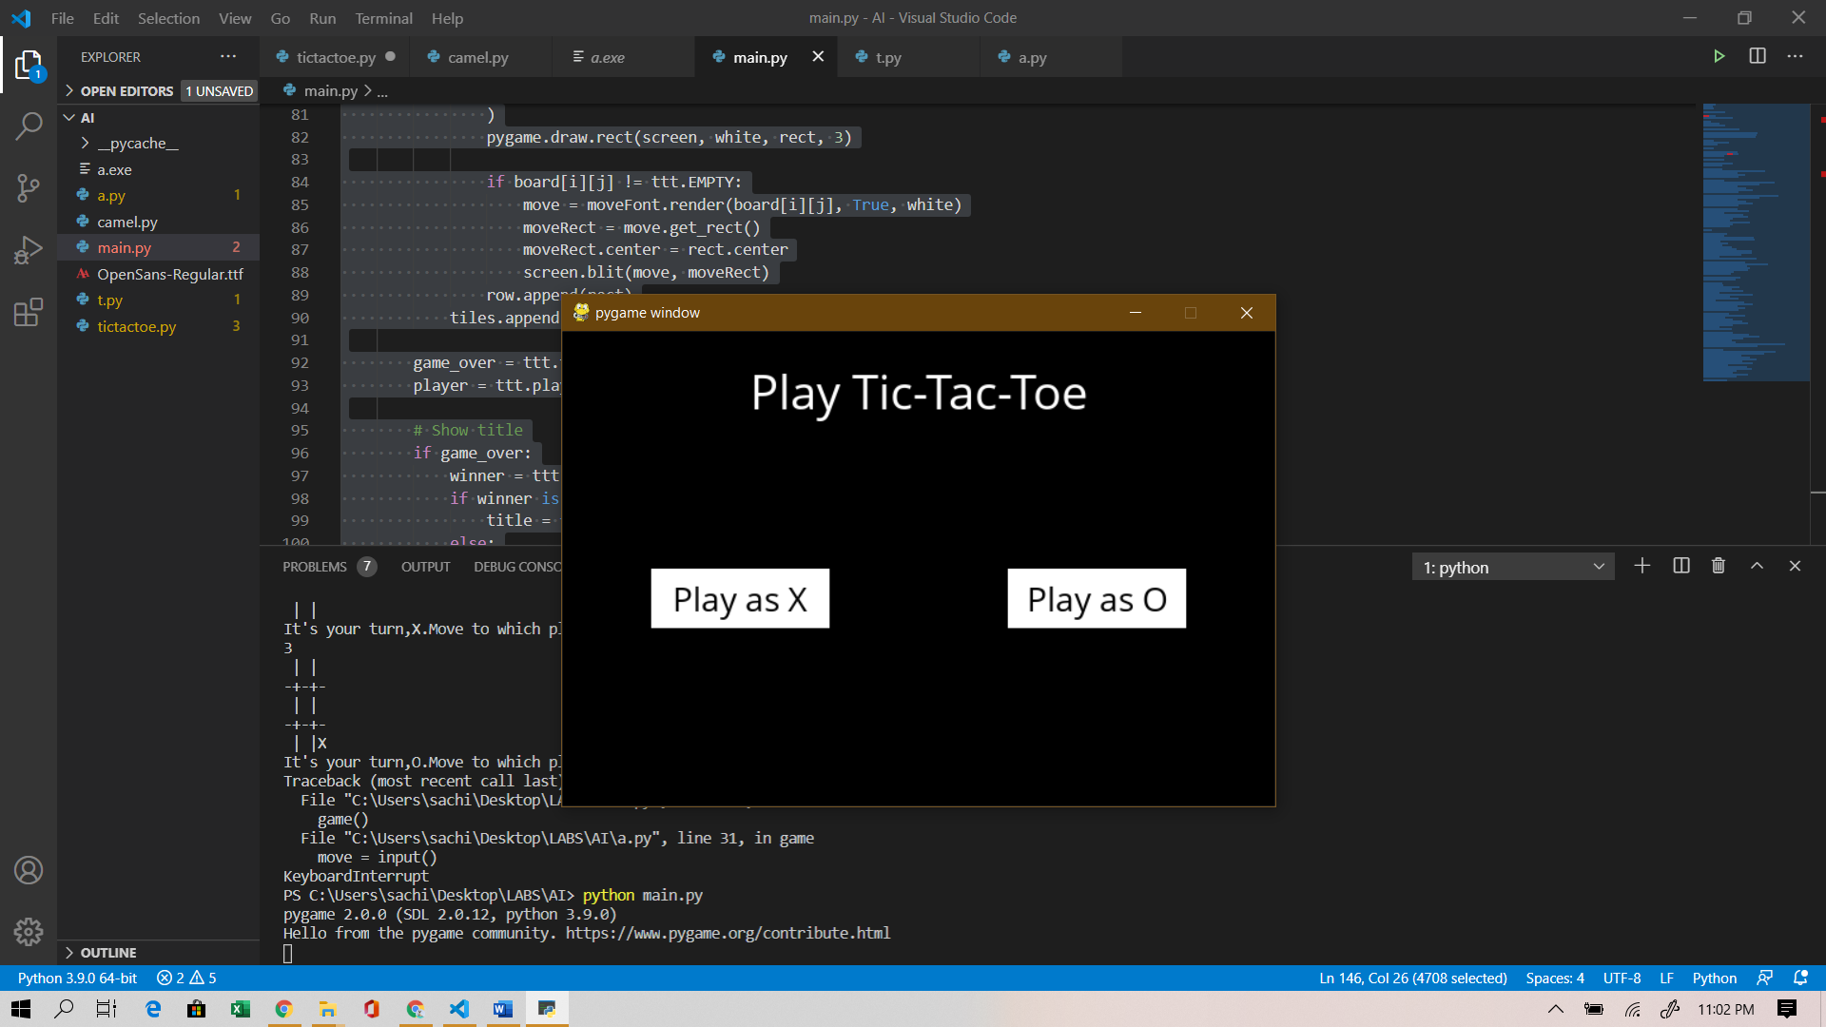

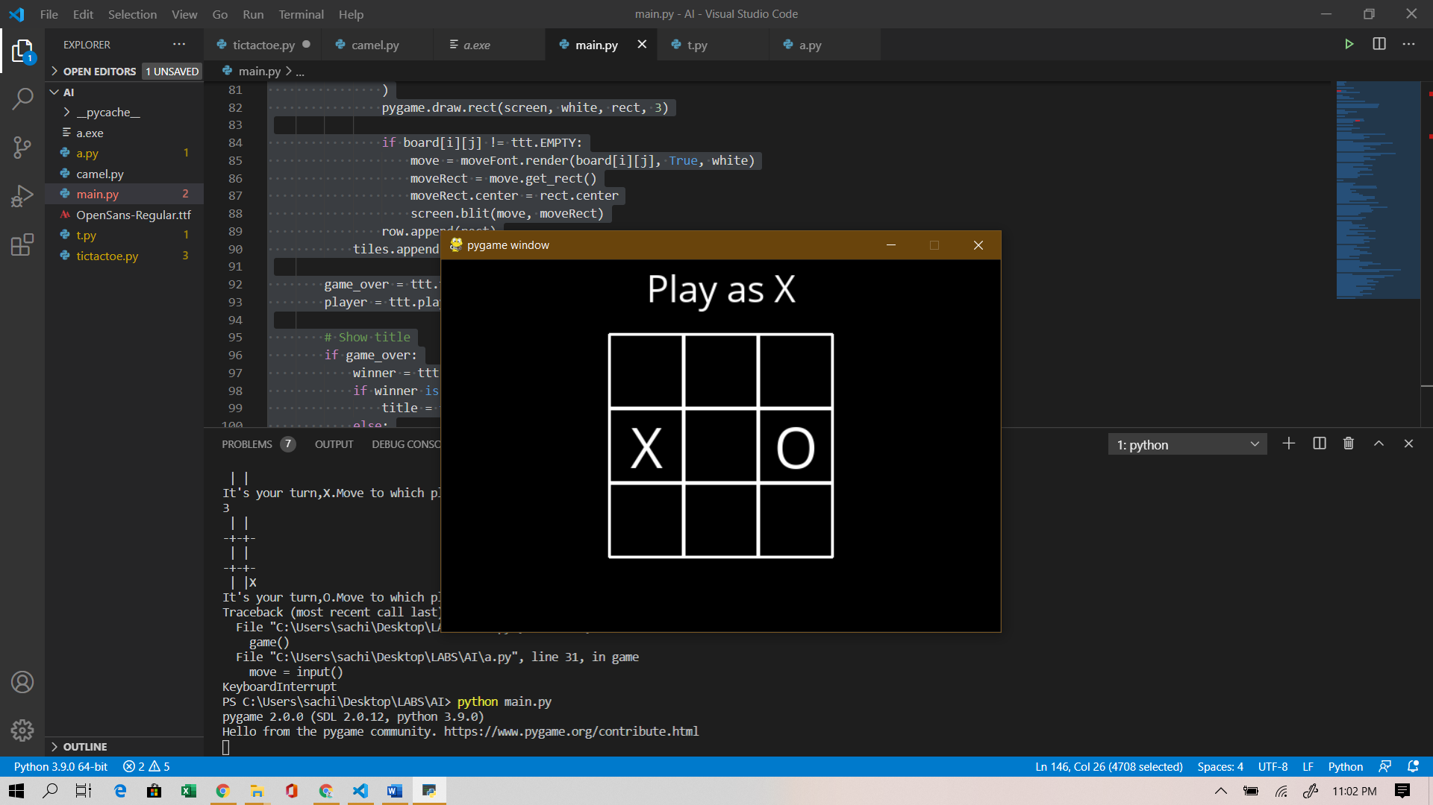

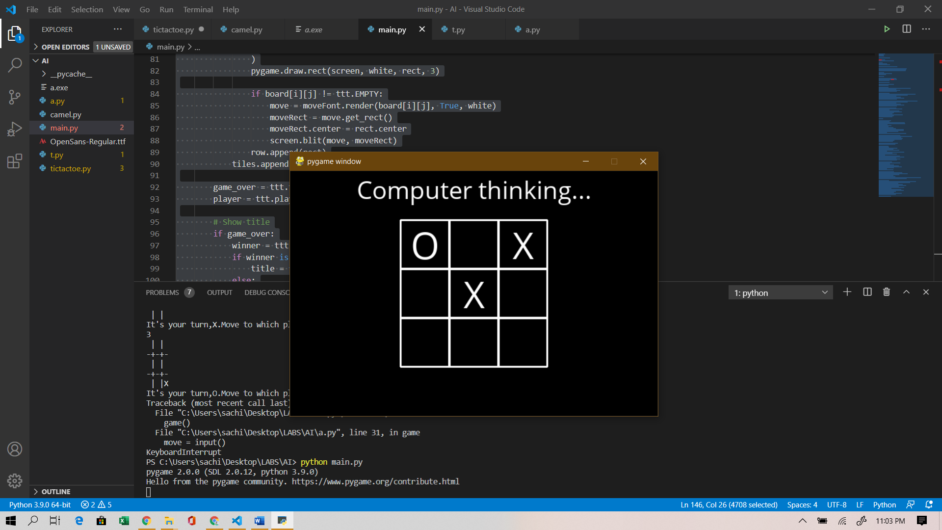

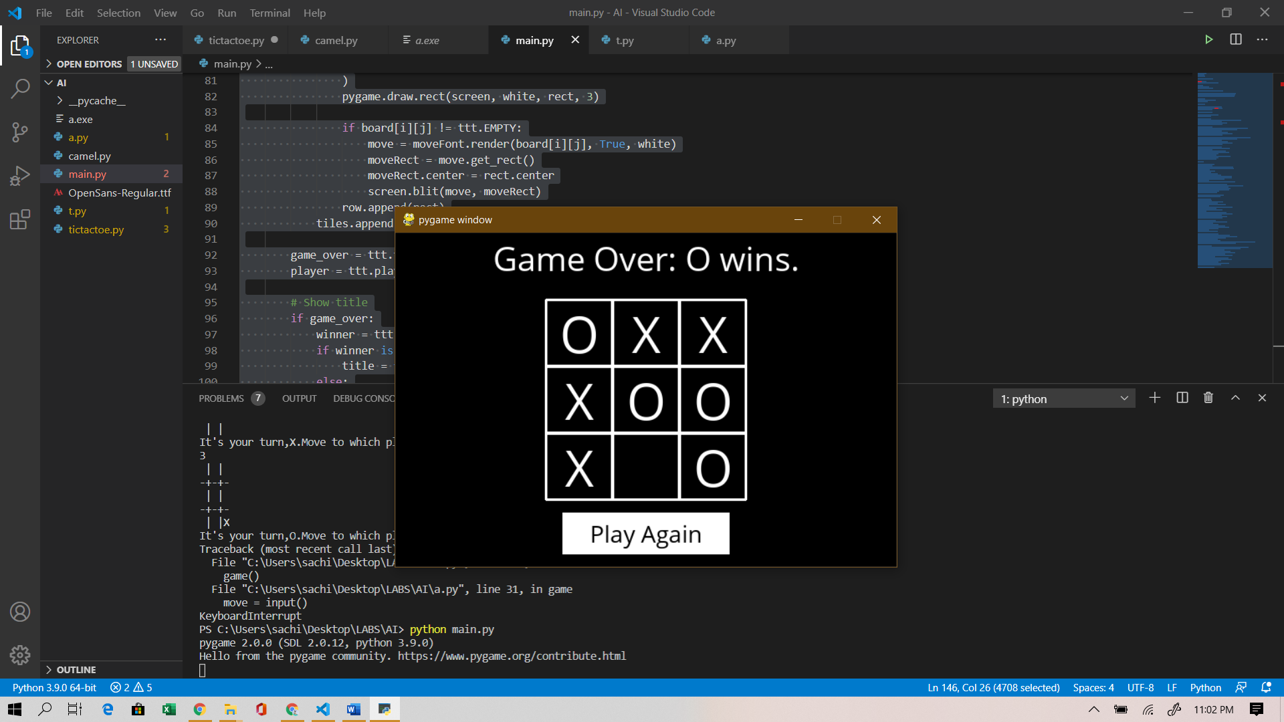

camel banana python code

total=int(input('Enter no. of bananas at starting: '))

distance=int(input('Enter distance you want to cover: '))

load_capacity=int(input('Enter max load capacity of your camel: '))

lose=0

start=total

for i in range(distance):

    while start>0:

        start=start-load_capacity

        if start==1:

            lose=lose-1

        lose=lose+2

    lose=lose-1

    start=total-lose

print("The maximum number of bananas to be transported is: ")

print(start)

